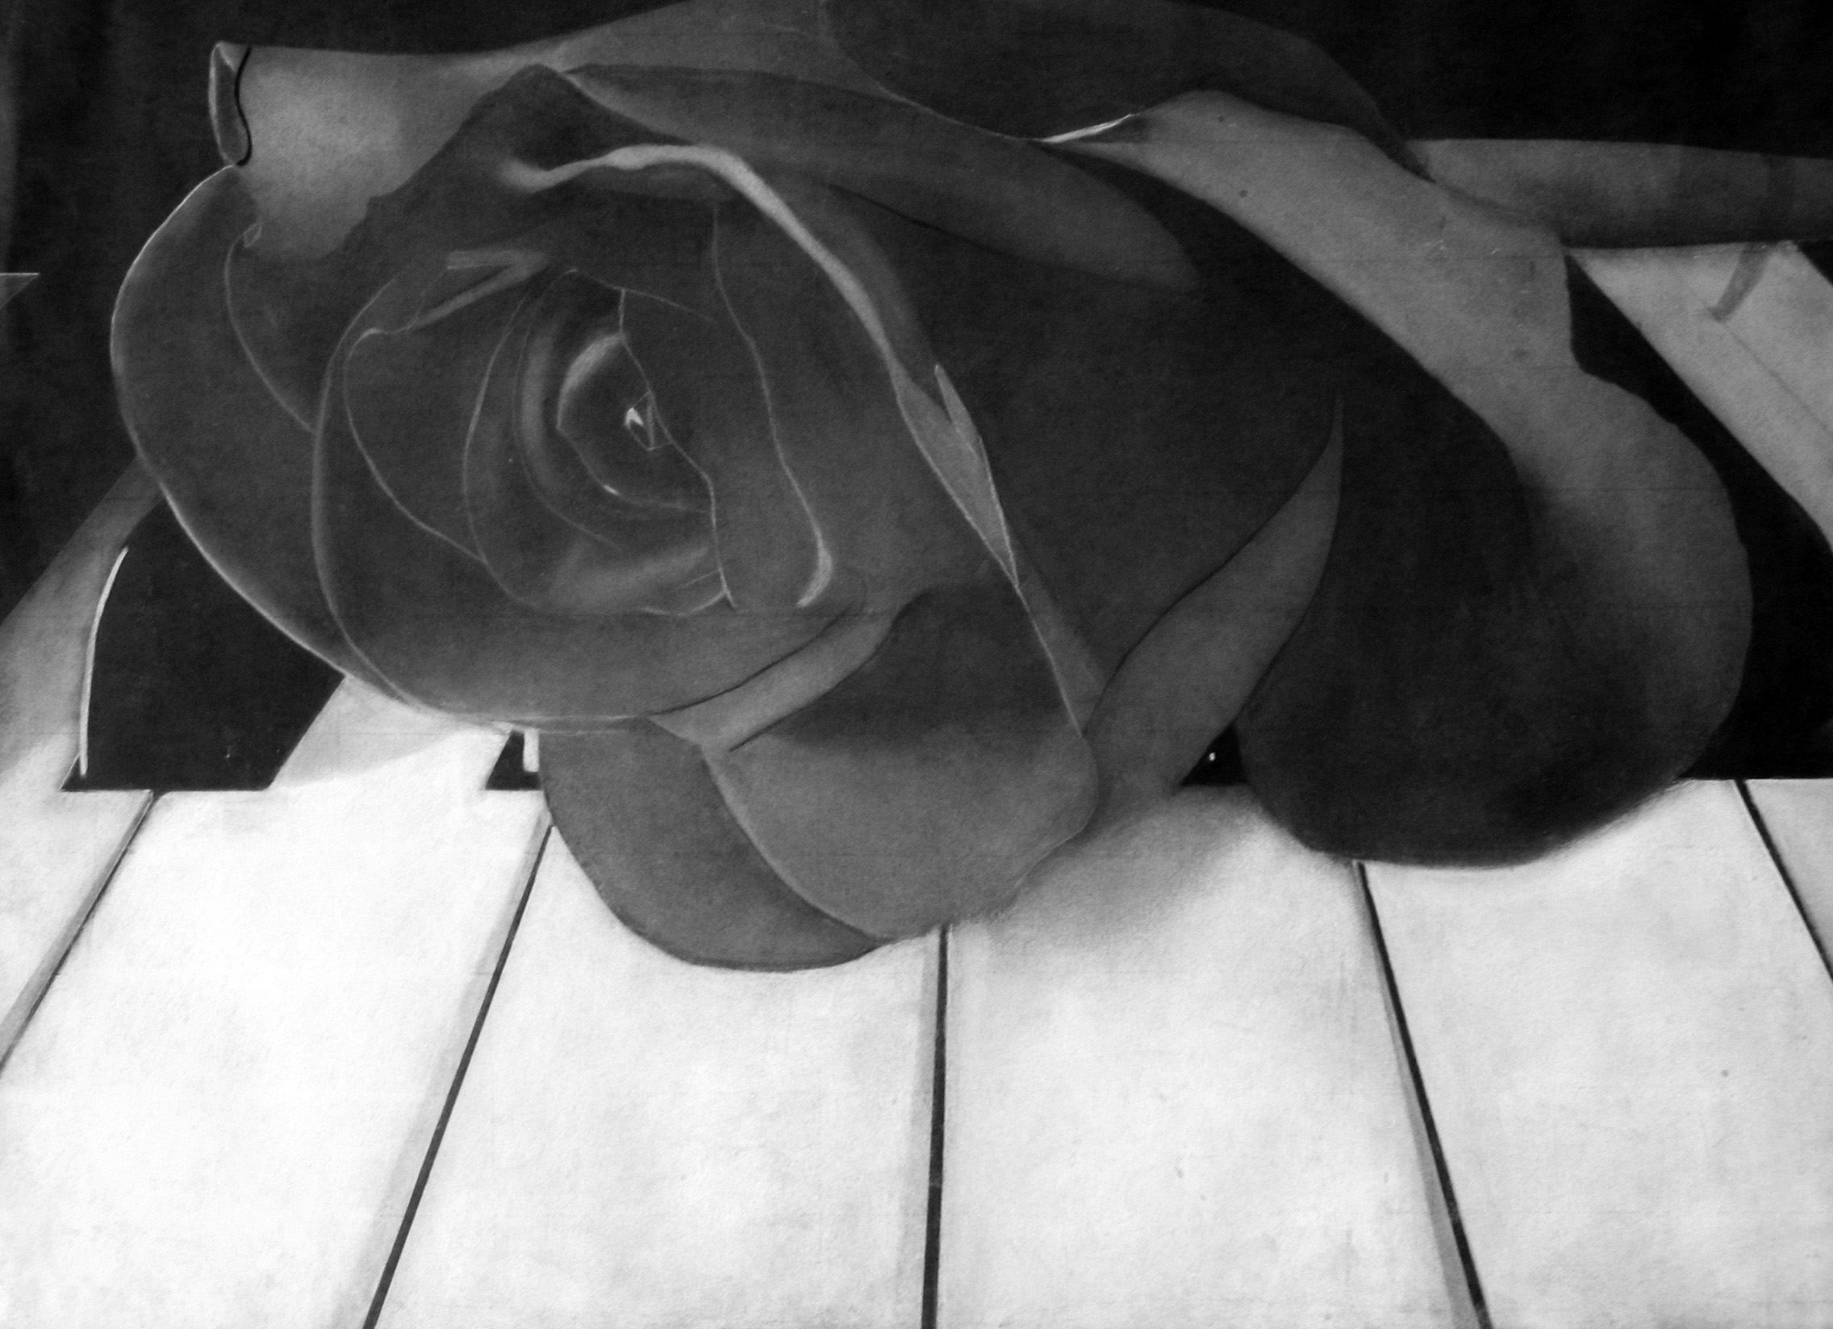
SEMESTER 1 FINAL
White Charcoal Drawing (300pts)
Final is worth 20% of your grade
*Students will copy a black and white photograph in white charcoal by using the blending and grid transfer technique.*
____/75pts Use of Elements/ Principles of Art & Design: Does your drawing look 3d/real? Student understands the concept of value in art, and can use charcoal to express a full range of values from black to gray to white in the blending technique. Completed drawing shows that range. Did you use the grid transfer technique.
____/75pts Creativity/Originality: YOUR PICTURE: Did you explore several choices before selecting one; generating many ideas; tried unusual combinations or changes on several ideas?
____/75pts Effort/ Participation: Were you productive? Did you work the entire period?

____/75pt Craftsmanship/ Skill : Did you use the entire space of the paper? Is your artwork beautiful and patiently done? Is your project as good as you could make it

How to start:
- Find your image on the internet.
- Right click and select “Save Picture As”, Save it to your pictures.
- Open Microsoft Word.
- Insert your picture.
- Select View Rulers
- Click on the photo, Click on the corners and drag to scale it up or down.
- Scale it to even numbers (for example, picture has to be 8”x 6”, instead of 8.5”x 6.25”)
- Minimum size is 6”x 6”
- Add the printer: click on printers on the desktop, find room 113 double click on the printer.
- Go back to Microsoft Word. Print your image to the room113 HP4014 printer.

