Getting to know you continues.........
PERSONAL IDENTITY DRAWING
Narrative Drawing: Tells a story
- Composition: Organization of your artwork/design. Divide your paper into 3 sections using straight or curved lines or both.  Line Quality  Horizontal Lines: Imply a state of rest or calm.  Curved Lines: Create movement  Diagonal Lines: Create a dynamic feel. | 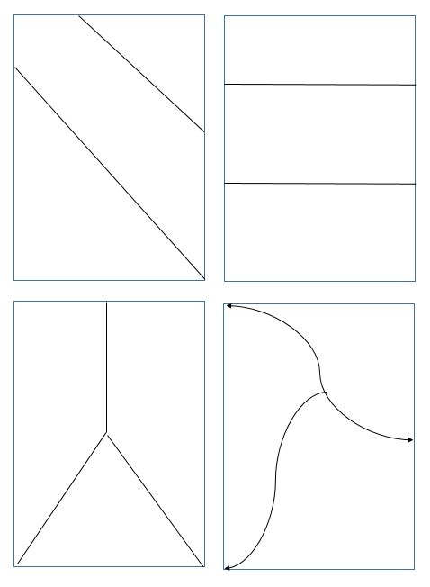

- Pick 3 memories from your early childhood to the present. (It could be about anything and everything you liked or disliked. Ex: having braces or glasses for the first time, pets, games, family holidays, events, your hobbies, etc.)  - Draw symbols that represent each memory in each section.  - 4) Label the memory #1-#3 and write one sentence describing the memory in each section.  - 5) Must have color  - Write your name and period # on the back side. | 