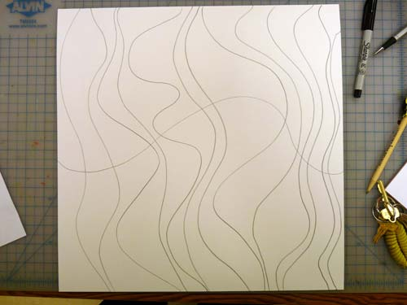 | 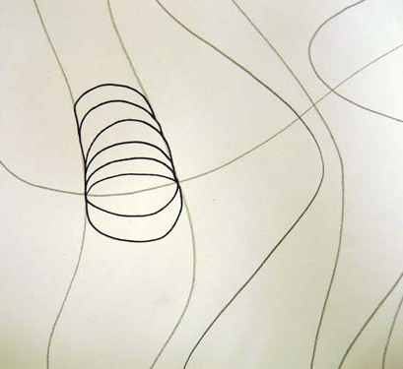
- In pencil Draw 9 Vertical Waves  - In pencil Draw a horizontal wave across the middle | In Pencil draw upward curves above the middle wave.  - Draw downward curves below the middle wave.
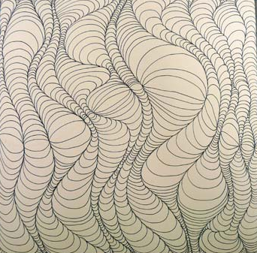 | 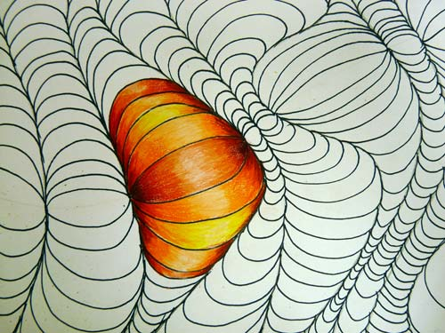
- Complete all the sections  - Trace over all the pencil with a black felt tip pen | - Color each section with gradating color from light to dark. Keep it light in the middle and dark in the sides of each section.
Optical Design
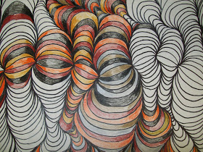
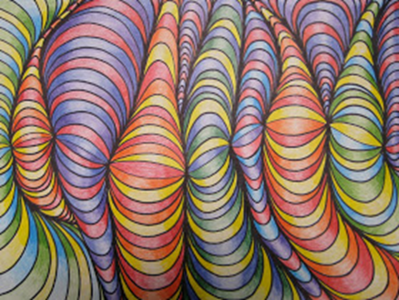
An abstract artwork that creates the illusion of movement, vibrating effects, patterns, an exaggerated sense of depth, or other visual effects.

