Name _______________________________Date _____
Value and Shading
Value refers to the dark and light areas of an object. It is what makes things look 3-Dimensional. Complete the value scales below with a #2 pencil and felt tip pen
3
4
5
6
7
2
1
BLENDING

Dark Light
CROSSHATCHING
STIPPLING
CROSSHATCHING
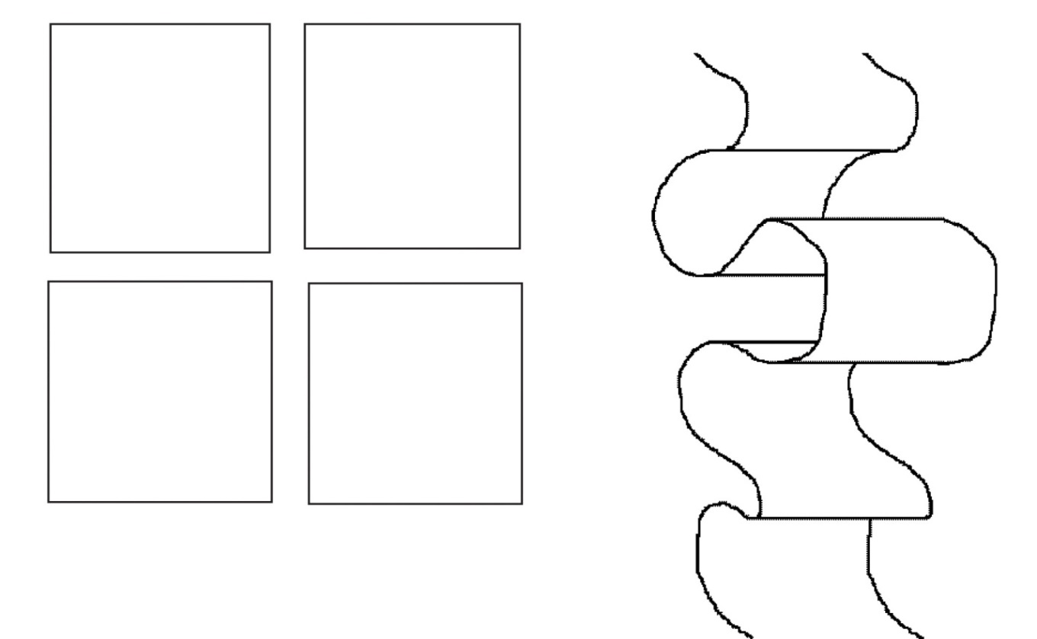
BLENDING
STIPPLING

