- PLACE COMPLEMENTARY PAIRS NEXT TO EACH OTHER
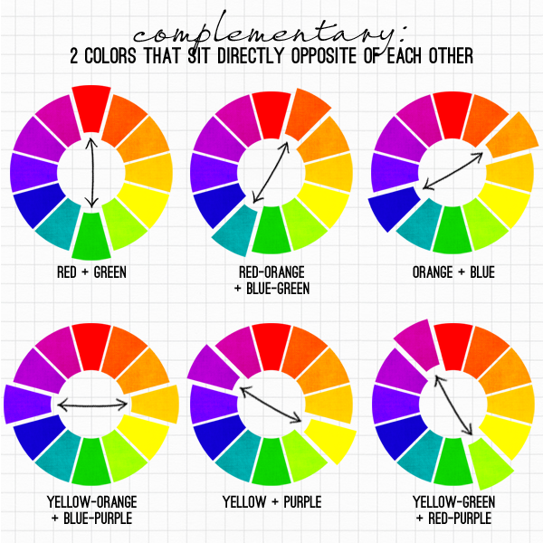
- CREATE A GRADIENT FROM DARK TO LIGHT IN EVERY SPACE

