18 7/16 x 24 1/4 + flap, Crystal Clear Bags Protective Closure (PC) (468x616) (100 pack) [B18PC]
12 7/16 x 18 1/4 Crystal Clear Bags Protective Closure (316x464) (100 pack) [B1218PC]
B&H #SELC67 • Mfr #LC67 lens cap
B&H #SECKL • Mfr #CK-L lens cap
Tripods
Glitter office depot Item # 950998

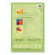 | Art1st® Watercolor Paper, 12" x 18", Pack Of 50 Sheets  Item # 814173

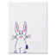 | Pacon® Tag Board, 24" x 36", 150 Lb, White, Pack Of 100  Item # 208648

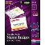 | Avery® Hanging Name Badge Kit, 3" x 4", Box Of 100  Item # 754421

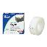 | Office Depot® Brand Invisible Tape, 3/4" x 1296"  Item # 520744
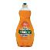 | Ultra Palmolive® Antibacterial Dish Liquid, 25 Oz.  Item # 250737

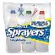 | 32 Oz. Sprayer Bottles, Pack Of 3  Item # 922005

Charles Leonard Camel Hair Paintbrushes, #6, Hair Length 11/16", Pack Of 12
Item # 461530

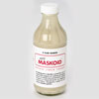  4100550 | Update | Delete | Art Maskoid® - 8-oz. Jar

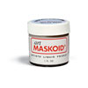  4100549 | Update | Delete | Art Maskoid® - 1-oz. Jar
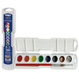  9700449 | Update | Delete | PRANG® 8-Color Oval Pan Watercolors Set  Volume Discount - $3.55 (16%)
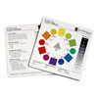  9709507 | Update | Delete | Color Wheel Class Set - Pkg. of 30, 7" x 7"
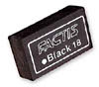  9716180(A) | Update | Delete | GENERAL’S® Factis® Magic Black™ Eraser
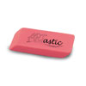  9730496 | Update | Delete | ARTastic® Pink Pearl Eraser - Medium
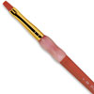  9727716 | Update | Delete | Big Kid’s Choice™ Brush - Flat, Size 4  Volume Discount - $1.25 (20%)
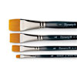  9730455 | Update | Delete | Dynasty® Finest Golden Synthetic Flat Brush - 1/4"  Volume Discount - $1.65 (9%)

Watercolor pencils item # 407491
Prang watercolor
Sharpeners 595651
Pencil boxes
General’s® Factis® Magic Black™ Erasers - Tub of 72
Nasco Premium Grade Tempera Pump Kit #1 - 4 Gallons
Nasco Premium Grade Tempera Paint - Black, Gallon
SD cards office depot
Card reader office depot

Helix® Hi-Polymer Professional Pencil CapErasers - Pack of 10, Black 9731463

Rubber bands item # 85685 office depot
Scissors
Color pencial set of 36 colors
BIG BLUE BRUSHES Dynasty® Sapphire Flat Brush - Size 14 9730485
Dynasty® Sapphire Round Brush - Size 10 9730491
Dynasty® Sapphire Round Brush - Size 2 9730487

Multi-Bin® BRUSH HOLDER 9709728

ALVIN® Heritage™ Cressida Aluminum Tabletop Easel 9726322

Small size bottles for paint Nasco Premium Grade Tempera Set A - 6 Quarts 9710356
Dynasty® Finest Golden Synthetic Flat Brush - ¼ 9730455
9703438 |  |  |  |  |  | GENERAL’S® White Charcoal Pencils – Pkg. of 12
9727581 |  |  |  |  |  | GENERAL’S® Compressed Charcoal White® Sticks – Set of 12
9721990 |  |  |  |  |  | Strathmore 300 Series Tracing Paper Pad – 9" x 12"
9722176 |  |  |  |  |  | Blending Tortillon Assortment – Set of 6
 | 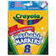 |  |  | Crayola® Washable Markers, Broad Line, Assorted Bold Colors, Box Of 8 Item # 950147
 | 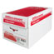 |  |  | Office Depot® Brand Copy Paper, 8 1/2" x 11", 20 Lb, Ream Of 500 Sheets, Case Of 10 Reams Item # 348037
 | 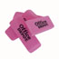 |  |  | Office Depot Value™ Pink Bevel Eraser, Large Item # 724920
 | 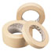 |  |  | Scotch® 2600 Masking Tape, 3/4" x 2160" Item # 666529
TB09472T |  |  |  |  | Helix® Graduate Compass
9704937 |  |  |  |  | Nasco 10-Well Snap Palette with Cover
9700800(G) Pentel® Sign Fiber-Tipped Pen $1.35 $1.26 $52.92
9715522(J) Tru-Ray® Fade-Resistant Construction Paper – Black, 18" x 24" $7.95 $31.80
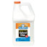 | Elmer's® School Glue, 128 oz  Item # 205351
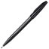 | Pentel® Sign Pens®, Fine Point, Black Barrel, Black Ink, Pack Of 12  Item # 257861
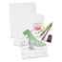 | Pacon® White Sulphite Drawing Paper, 80 Lb., 12" x 18", Ream Of 500 Sheets  Item # 172726
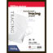 | Office Depot® Brand Heavyweight Tracing Paper, 9" x 12", Pad Of 50 Sheets  Item # 309699
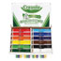 | Crayola® Color Pencils Classpack, Set Of 240  Item # 353674
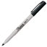 | Sharpie® Extra-Fine Point Permanent Markers, Black, Box Of 12  Item # 447201
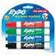 | EXPO® Low-Odor Dry-Erase Markers, Chisel Point, Assorted Colors, Pack Of 4  Item # 497735
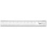 | Westcott® 18" Acrylic Ruler  Item # 434132
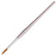 | Loew-Cornell® American Round Painter Brush, #4, 7 1/4"  Item # 216728
Loew-Cornell® American Round Painter Brush, #1, 6 3/4"
Item # 216712
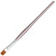 | Loew-Cornell® American Shader Painter Brush, #2, 6 3/4"  Item # 216816
Pacon® Tag Board, 24" x 36", 150 Lb, White, Pack Of 100
Item # 208648
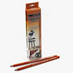  9702857(B) GET SOFT INSTEAD! | Update | Delete | General’s® Charcoal Pencils - HB Hard, Pkgs. of 12  Volume Discount - $10.55 (10%)
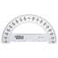  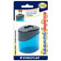Staedtler® 2-Hole Metal Pencil Sharpener  Item # 595651 | Office Depot® Brand Semicircular 6" Protractor, Clear  Item # 713585
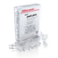 | Office Depot® Brand Pushpins, 1/4" Head, 1/2" Length, Clear, Pack Of 200  Item # 825265
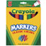 | Crayola® Conical Tip Markers, Assorted Classic Colors  Item # 950055
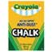 | Crayola® Anti-Dust® Chalk, White, Box Of 12 Sticks  Item # 949339
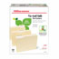 | Office Depot® Brand 30% Recycled File Folders, 1/3 Cut, Letter Size, Manila, Pack Of 100  Item # 810838

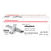 | Office Depot® Brand Staples, 1/4" Standard, Full Strip, Box Of 5,000  Item # 766967
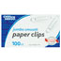 | Office Depot® Brand Paper Clips, Jumbo, Silver, Box Of 100 Clips  Item # 429175
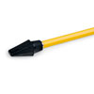  9731463 | Update | Delete | Helix® Hi-Polymer Professional Pencil CapErasers - Pack of 10, Black  Volume Discount - $1.05 (10%) | $0.95 | $28.50
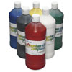  9710356 | Update | Delete | Nasco Premium Grade Tempera Set A - 6 Quarts | $51.50 | $51.50
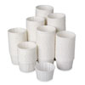  W05545 | Update | Delete | Disposable Paint Cups - Pkg. of 250  Add 3 more to receive a discount price of $10.26 | $11.45 | $11.45
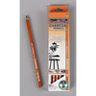  9702857(C) | Update | Delete | General’s® Charcoal Pencils - 4B Soft, Pkg. of 12  Volume Discount - $10.50 (10%) | $9.49 | $75.92
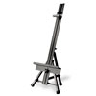  9726322 | Update | Delete | ALVIN® Heritage™ Narvaez Aluminum Tabletop Easel | $30.95 | $154.75
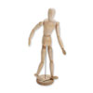  0300425 | Update | Delete | Male Wood Manikin - 16"  Volume Discount - $10.65 (22%) | $8.36 | $100.32
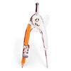  1100679 | Update | Delete | Ball Bearing Compass  Volume Discount - $0.90 (8%) | $0.83 | $16.60
Merchandise Subtotal: |  |  |  | $439.04
Printer friendly version. |  |  | Total: | $439.04

