Name _______________________________
Who? What? Where? When? Why?
Directions: Find 25 artists or artworks and answer the questions for each.
- WHO is the artist? | Salvador Dali
- WHAT is the name of the artwork? (Include an image.) | “The Persistence of Memory”  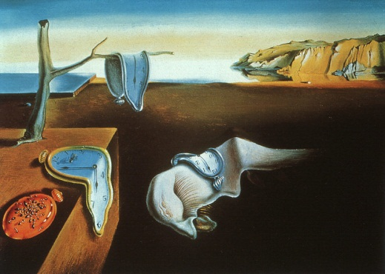
- WHAT is the medium? (The medium is the type of material used to create the artwork.) | Oil on canvas
- WHERE did you find it? (Include the website URL or name of the book/magazine.) | The MOMA collection: Salvador Dali  http://www.moma.org/collection/object.php?object_id=79018
- WHEN was it created? (The date it was made or published.) | 1931
- WHY did you choose it? (You must write more that “I like it” or “It’s pretty” or “Because it’s awesome”. Do not just give your opinion, give a thoughtful response to this question and include a discussion of the elements and principles of art.)

I chose this painting because I like how the idea of time being powerless is shown in a dreamlike landscape. Dali paints the clocks and face as organic forms to show that they are melting away or deteriorating. The use of light and dark values make the objects appear 3-dimensional and create a lot of space between the foreground objects and the sky, water, and mountain in the background. He uses a complimentary color scheme of blue and orange tones. The placement of the color blue helps to move your eye throughout the painting. The composition is asymmetrical as there is more visual weight on the left side of the painting, but the mountain in the upper right of the painting acts as a counter balance.

